**Jan.2022**

Women Leaders Program

who are able to meet the challenges of today and thrive in the world of tomorrow**___**

Center of Education for Sustainable Development

At Heliopolis University

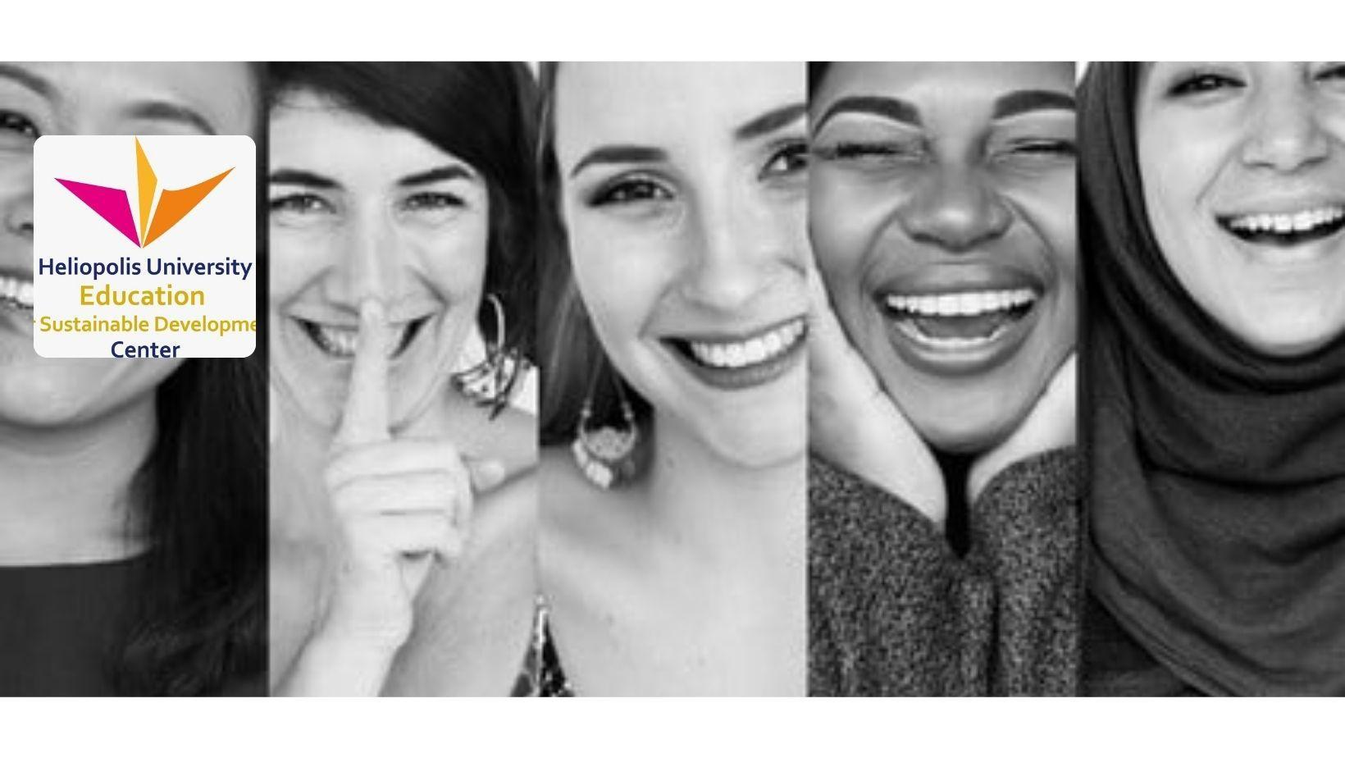

## Overview

**The Women Leaders Program of CESD** envisions a healthy and vibrant society where women and men understand their roles in families and society, respect one another, promote gender equality in daily life and workplace and live and work in harmony to create a sustainable culture.

To be in line with our vision, we provide a program for women leaders to make a pause in their daily routine and to create time and space to be mindful and review on one’s personal lifestyle, work dynamic in professional life and a world view. In our co-creative space, we offer them ongoing support to accompany them to unfold their potential and grow their careers through communal shared tools and resources, workshops, seminars, networking events and more.

Our mission is to create a community of women leaders that will give them access to a supportive environment while being able to connect talented professionals with our apartments who value diverse and inclusive culture including race and gender equality.

The custodians of this mission are a committed group of professionals, who have been sharing their respective fields in education, culture , social, therapy and environment and who are working with the Sustainable Development Goal (SDG) by the United Nations(UN).

We aim for women leaders with diverse backgrounds to learn and practice a more holistic and sustainable perspective on life, to build more resilience for working with challenges they face in their personal and work life and to take responsibility for pioneering a possible future.

## Principle : *\*extract from ‘The rising women rising world’*

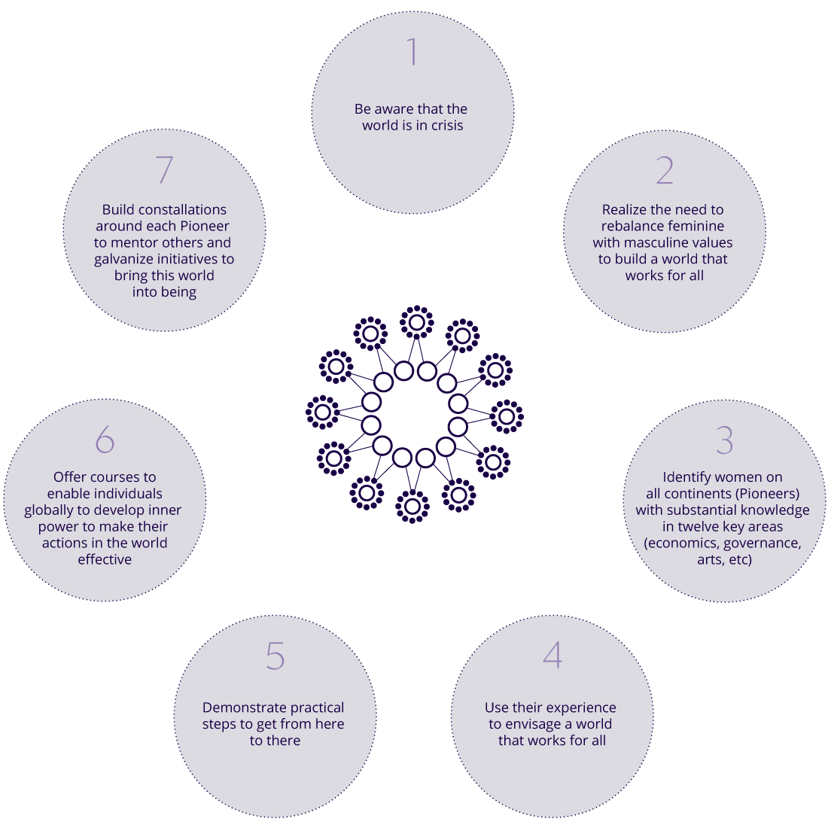

## Three stages of a transformational journey

The main flow of the program will be in three stages to support the unfolding potential of each individual and to enhance collective resilience for social change. We care for this process to be step by step. The seed of transformation begins with sensing the need of women in their personal and work life which opens a space for questions on how to transform the society as a whole.

### STEP 1: Unfolding your potential through awareness on well-being and your own creativity

We believe that inner work is a prerequisite for router effectiveness, for the simple reason that the quality of our awareness directly affects the quality of results produced. If we want to communicate clearly, transform conflicts, generate energy , and develop trust within our families, in our places of work , our first challenge is to do the inner work. So we invite participants to address individual questions and needs as a woman in a family, work environment and society as the first step. And we guide them to dive into knowing oneself on a deeper level through observing self-behaviors, personality and temperament. And we use the methodology of reflecting one’s own biographical events and working with creativity through diverse artistic activities of painting, movement, storytelling and psychodrama technique etc.

**STEP 2 : : Feminine and Masquline principle in relation with personal, social and global challenges.**

We introduce two archetypal dynamics of life ‘Feminine and masquline principles’ in the evolution of humanity from different cultures : the contendings of Horus and Seth in ancient Egypt, the relationship between mother earth and father sky in the native american culture, the principle of Yin and Yang in ancient Chinese and far east philosophy, analytics psychology etc. and we let participants explore the unique qualities of feminine and masculine soul principles and recognize how these characteristics are evident in one’s personal and work life. These principles are defined separately but considered to be of equal significance in both men and women and are not limited to gender. Understanding these qualities can help participants to relate to the current challenges and issues of the world with a wider perspective.

### Step 3: The Balanced & Mindful Leaders

The new brand of leaders that we need are the ones who know and live the connection between inner self-development and outer action, who recognise the importance of the co-emergence of the feminine and masculine qualities and who integrate those knowledges in their personal life as well as in their work environment with a more balanced perspective. This stage, participants will be exposed mainly to group work in order to practice their mindful leadership skills: presenting case studies, asking questions and exchanging feedback and creating a network of women leaders for continuous support after completing the program.

## Beneficiaries

Women leaders who are working in the field of higher education and NGOs in Egypt which aims to create a sustainable future ;

* Educators, professors and teachers.
* Artists
* Social workers and facilitators
* Doctors, counselor, therapist, psychologists
* Project managers

Membership :

* the retreat program
* Sharing profiles on newsletter
* network building

## 

## 

## Program overview 2022

Program for staff at Heliopolis University and open course for participants from other institutions.

### H.U _Women empowerment - Round table - Weekly

This initiative has been led by the women leaders committee of Heliopolis University since September 2020. It provides a space where women staff can discuss matters, share their experiences and challenges regarding cross-cultural communication and increase awareness on women related topics on health and well being. It aims to create H.U a safe space for women and men to work at eye level and encourage women to their real strength and individual potential.

### H.U_Women’s Forum - Monthly

We define the topic each month to discuss and to present the new ideas which are related with women’s issues and promote gender equality.

### H.U_E.S.D course for Academic staff

Winter and summer vacation program.

### Open course _ Women seminar “El Aish” at SEKEM farm

It is a residential training program for deepening knowledge on self-development and cross -cultural communication and conflict resolution. SEKEM vision goal introduction. We invite the trainer who is an expert in different fields in Egypt and in the world.

### Open course _Women’s Initiatives Forum at H.U

expert in different fields in Egypt and in the world.

### H.U_International Women’s day by UN

### 8th March

In line with United Nature the International Women’s day. We invite different initiatives and NGOs who are working with Women empowering , women's rights . sharing our vision and creating a new culture. We aim to invite more students and staff and men and women to celebrate our peace building.

### H.U_International day of elimination violence against women by U.N

### 25th November

Bringing awarness into what domestic violence is , open space for discussing the social issues for example, ineuality in gender, FGM and early childhood marrige.

## Proposed timeline 2022

|  | **Q1** |  |  | **Q2** |  |  | **Q3** |  |  | **Q4** |  |  |
| --- | --- | --- | --- | --- | --- | --- | --- | --- | --- | --- | --- | --- |
| Program /Month | Oct | Nov | Dec | Jan | Feb | Mar | Apr | May | Jun | Jul | Aug | Sep |
| Weekly sessions @ H.U |  |  |  |  |  |  |  |  |  |  |  |  |
| Monthly Women's Forum |  |  |  |  | 24th | 10th |  |  |  |  |  |  |
| Quarterly seminar |  |  |  |  |  |  |  |  |  |  |  |  |
| Women leaders Forum |  |  |  |  |  |  |  |  |  | Summer forum |  |  |
| Survey @H.U |  |  |  |  |  |  |  |  |  |  |  |  |
| Newsletter / article |  |  |  |  |  |  |  |  |  |  |  |  |
| International women's day |  |  |  |  |  |  |  |  |  |  |  |  |

## 

## 

## Trainers - Egyptian and International *\*still in conversation to collaborate*

* Dr. Rama Mani - Theater of transformation
* Menna Sayed - Diversity and inclusiveness
* Dr. Anita Charlton - Biography coach
* Dr. Scilla Elworthy - Peacebuilding & conflict resolution
* Dr. Naela Reffat - Active citizenship and Gender Equality
* Mona Abouleish - Holistic Child Education
* Regina Hanel - Holistic Early childhood education
* Petra Rosenkranz- Art therapy
* Nana Woo - Mindful leadership / Movement art

**Partnership - Egyptian and International *\*still in conversation to collaborate***

**\***In contact with Egyptian NGOs through the Social Initiatives Forum

* Home for Humanity , Switzerland
* Rising women Rising world , UK
* Misriyati , Egypt

**Testimonial**