**Jan.2022**

Young Leaders program

who are able to meet the challenges of today and thrive in the world of tomorrow

**___**

Center of Education for Sustainable development

At Heliopolis University

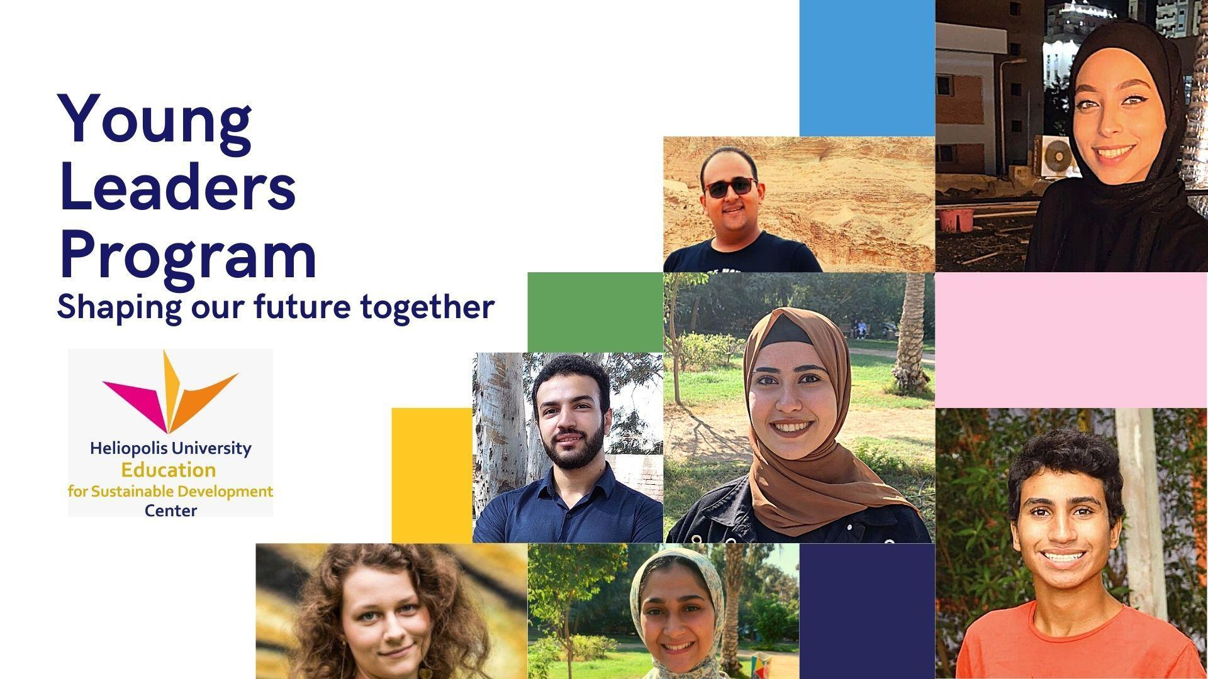

# INTRODUCTION

Since humanity moved from an agrarian society to industrial society, is moving from the extended family to the nuclear families, from collectivism to individualism and with the growth of capitalism and materialism, it seems that humans have become more and more beings of self-interest. In this culture, choices of how to live life are too limited for young people. We need a new social organism which balances between new Individualism and new Collectivism. Young people today need a space to reconnect with a healthy social life: the healthiness of relating with each other and with oneself. It is necessary that this is done on the level of experience rather than theoretical work - otherwise the healing doesn’t happen. We need a radical change of the system of universities for future leaders. Young people need a university where there is a holistic community and where each person is active in personal and social development which leads them to take responsibility in social transformation.

## Overview

**The Youth Leaders Lab (YLL)** is a learning programme designed to provide a space for young adults to address questions about life and current society, exchange their ideas for creative solutions for a more sustainable future and apply them into real life. Through its framework, content and methodology, which strongly builds on peer to peer learning, reflection and community building, this YLL will enable young adults to gain fresh insight and develop new approaches to life. The programme offers a set of applied learning modules and tools for practice–based learning and gives the participants opportunities to create their own initiatives and give them the confidence to step into leadership and to build meaningful collaborations.

## Aim

The YLL aims to research and co-create a new model of an education system for future leaders where young adults are involved in the whole process itself, from design to execution. The YLL is the first step in prototyping the seed of a new type ofnew university. Together we will imagine a new social organism which creates a balance between a new individualism and a new collectivism. (explain what these two things are)

## Desired Outcome

Participants are able to understand the foundation of life and what it means to be human. Through this there will be healing for the local “society” it forms and this will in turn ripple out from the actions that participants make as a consequence of the programme

* To have a real experience of a healthy social life of the future as an anchor point so they can trust and take initiatives wherever they are.
* To gain a sense for healthy balance between time for oneself and others.
* To make decisions more consciously, working with intuition and trust.
* To connect with ‘my purpose’ through caring for others, society and the environment
* To live life fully & to enjoy life.
* To understand the Sustainable development goals of the UN and create an initiative and action plan in their own communities.

## Need of the world

##### YLL addresses two important needs in the society

### From Selfishness to true individuality

Alongside heavily intertwined with ‘Me’ culture (my fashion, my phone, my car, what I like, what I value, my dream, I don’t have enough time etc) is the growing problem of social isolation amongst young people and an alarming rise in the number of young people taking their own lives. Furthermore the way our current society is constructed doesn’t nurture people towards caring for others, society and the environment. so we need to imagine a new image for the society: a more wholesome, sustainable and collaborative society. We need to explore new ways of community building which will serve to create more health individuals within a collective environment

### Understanding what LIFE is

Driven by economic growth, more and more people are going to universities so that they can get a ‘better’ job, but at the same time a lot of young people haven't had space and time to explore what they really want to do in life, Today, most universities are very much separate from real life; they often don’t provide what a young person truly needs to be a healthy human being and to be part of a healthy society. So the number of young people who are taking Gap year is growing. Where can these young people go? where they can have space to learn and reflect about oneself and the bigger purpose of their lives with others? The YLL is the space and time for young people who are searching for something different, something new.

## 

## Threefolds Principle

##### I & YOU & WE

### Creating space for oneself

Art of slow down in this fast-paced society, Beauty of holding questions rather than getting an immediate answer. Being with silence rather than filled with thoughts and noises in mind. Having inner peace for resilience for burnout symptoms.

### Stepping in to leadership

New leadership is to keep balance between taking responsibility and trusting others. take a responsibility not only for myself but for others. how to learn to make a first step to the action to serve others. Let 'I' shine in service to you '

### Building a social body ME to WE

It is not about ignoring individuality in society. It is about being conscious of Individuality within society. " I in We " sense of togetherness,sense of belonging, care for others and environment.

## Methodology

##### New imagination for young adults education

### Peer to peer learning

Each participant will bring their own gift, skill and what they have learned from faculties to facilitate sessions or presentations in different subjects to their peers. Through this participants will get inspired to take initiatives, learn self-trust and how to support one another and to not be afraid of failures. The programme will be defined only when we have a list of final participants.

### The grounding work

Participants will self-organize to take responsibility for daily tasks such as shopping, cooking, washing clothes and dishes, cleaning the house, recycling, composting food, etc to experience the practical tasks need to be done in life and to discuss about each tasks and deeper meaning : ex: where food come from/ what is the process of recycling etc .

### Money talk

Participants will explore different ways of relating to finance (the exchange, gift economy ) and creative ways of raising required funds, through crowdfunding, writing funding proposals and experimenting with alternative funding models.

### External inspiration

We will invite experts who are actively working in different fields of sustainability to hear their stories on how they work with challenges and opportunities, to get inspired and to learn practical knowledge.

### Dialogue with mentors

Participants will learn to build a relationship with mentors in the wider community. so when they need support mentally, emotionally there will be a circle of elders who can listen with authentic ears .

### Creating space for oneself

Burn-out is such a big problem in our current society. People are always required to be ‘switched on’ and to strive for more. We get less and less time to spend with ourselves, to listen to what we really need at a deeper level. The YLL will support participants to create space to reflect and grow.

## Youth (beneficiaries)

##### 19 ~ 28 years old with different cultural, social, political, economic backgrounds.

* Students and alumni from Heliopolis University
* Students from universities in Egypt
* Students from other countries

who sees the challenges in the world and strives for creating a more wholesome society.

who are interested in community building.

who are open to different ways of thinking.

who are willing to work hard practically and creatively

who are willing to listen and work with others through difficult times as well as joyful times.

## Program overview 2022

### H.U _ the Youth Leaders Lab(YLL) club

##### Student activity for members of the YLL students club at Heliopolis University. It will be guided by the mentor circle of the ESD center and Social initiative forum network.

### H.U _ Young Leaders Forum

##### Each semester, the YLL club organizes an open event where they invite more students from Heliopolis University to practice their leadership capacity to present different topics they have learned and facilitate conversation among students.

### Egypt _ Young Leaders Forum

##### Each semester, the YLL club travels to different cities and organizes an open event for meeting young leaders from other universities in different areas to exchange their research and ideas for the creating a sustainable future

##### / Cairo Hub / Alexandria Hub / Luxor Hub /

### International _ Youth Summer School - July

##### In the summer vacation, the YLL of Egypt invites young changemakers from other countries to participate in a week-long residential program where intercultural dialogues are practiced : gender, religion, generations, nations and races. It will be held at SEKEM farm in Egypt.

### International_ Youth Colloquium - December

##### partnership with the Youth Section in Switzerland. Young leaders from Egypt can meet international young leaders. Three days program

### International _ Youth Initiative Forum - April

##### partnership with Youth Initiative Program (YIP) in Sweden. It is an annual conference hosted by and for people who want to enact positive change in the world. It is a space of learning, inspiration, networking and collaboration. Participants can come to share and learn about initiatives for change from around the world. It combines lectures, personal stories, workshops, discussions and celeration into a week that will awaken the intellect, warm the heart and rejuvenate the spirit.

##### 

## Proposed timeline 2022

|  | **Q1** |  |  | **Q2** |  |  | **Q3** |  |  | **Q4** |  |  |
| --- | --- | --- | --- | --- | --- | --- | --- | --- | --- | --- | --- | --- |
| **Program /Month** | Oct/2022 | Nov | Dec | Jan/2022 | Feb | Mar | Apr- Ramadan | May | Jun | Jul | Aug | Sep |
| Weekly sessions @ H.U |  |  |  |  |  |  |  |  |  |  |  |  |
| Local Youth forum |  |  |  |  |  |  |  |  |  |  |  |  |
| Int.Youth Forum |  |  | Switzrland |  |  |  | Sweden |  |  | Summer school |  |  |
| Facebook/ social media |  |  |  |  |  |  |  |  |  |  |  |  |

## Trainers *\*still in conversation to collaborate*

* Junior trainers : who are in higher education study
* Hasnaa , Alexandria University
* Heba, Business faculty at Heliopolis University
* Senior trainers : who have graduated from higher education.
* Hadeel : Empathy
* Dina, Marwan from Greenish : Environment crisis
* Mariam Dahab , former SEKEM intern, AUC future leaders program.
* Mentor circle:
* Nana woo , ESD centre
* Noura , Nelly from Misriyati
* Hana Shawer , Core program at Heliopolis University
* Justus harm : Mindfulness leadership
* Ahmed Sameh: Emotional intelligence from Emmkan
* Jacoub : Philosophy and Drama
* Wiser circle :
* Dr.Hassan : biodiversity in environment and humanity
* Naila : the director of ESD centre
* Mona Abouelish : the board directors of ESD center

## Partnership *\*still in conversation to collaborate*

* Youth Section in Goetheanum, Switzerland
* World Social Initiative Forum
* Home for Humanity , Switzerland
* ASHA center , the UK

“I beg you, to have patience with everything unresolved in your heart

and to try to love the questions themselves as if they were locked rooms or

books written in a very foreign language.

Don’t search for the answers, which could not be given to you now,

because you would not be able to live with them.

And the point is to live everything.

Live the questions now.

Perhaps then, someday far in the future,

you will gradually, without even noticing it,

live your way into the answer.”

― Rainer Maria Rilke, Letters to a Young Poet